Raffles Institution
2026 Year 6 Preliminary Examinations

Level: Year 6 H2 Geography Paper 1 Time: 3 hours
9173/01

Raffles Institution Raffles Institution Raffles Institution Raffles Institution Raffles Institution
Raffles Institution Raffles Institution Raffles Institution Raffles Institution Raffles Institution
Raffles Institution Raffles Institution Raffles Institution Raffles Institution Raffles Institution
Raffles Institution Raffles Institution Raffles Institution Raffles Institution Raffles Institution
Raffles Institution Raffles Institution Raffles Institution Raffles Institution Raffles Institution
Raffles Institution Raffles Institution Raffles Institution Raffles Institution Raffles Institution
Raffles Institution Raffles Institution Raffles Institution Raffles Institution Raffles Institution
Raffles Institution Raffles Institution Raffles Institution Raffles Institution Raffles Institution
Raffles Institution Raffles Institution Raffles Institution Raffles Institution Raffles Institution
Raffles Institution Raffles Institution Raffles Institution Raffles Institution Raffles Institution
Raffles Institution Raffles Institution Raffles Institution Raffles Institution Raffles Institution
Raffles Institution Raffles Institution Raffles Institution Raffles Institution Raffles Institution
Raffles Institution Raffles Institution Raffles Institution Raffles Institution Raffles Institution
Raffles Institution Raffles Institution Raffles Institution Raffles Institution Raffles Institution
Raffles Institution Raffles Institution Raffles Institution Raffles Institution Raffles Institution

READ THESE INSTRUCTIONS FIRST:
This Insert contains all the Resources referred to in the question paper.

INSERT

Resource 1 for Question 1
Changes in economic sectors of More Economically Developed Countries (MEDCs) and Less Economically Developed Countries (LEDC) from 1950 to 2020

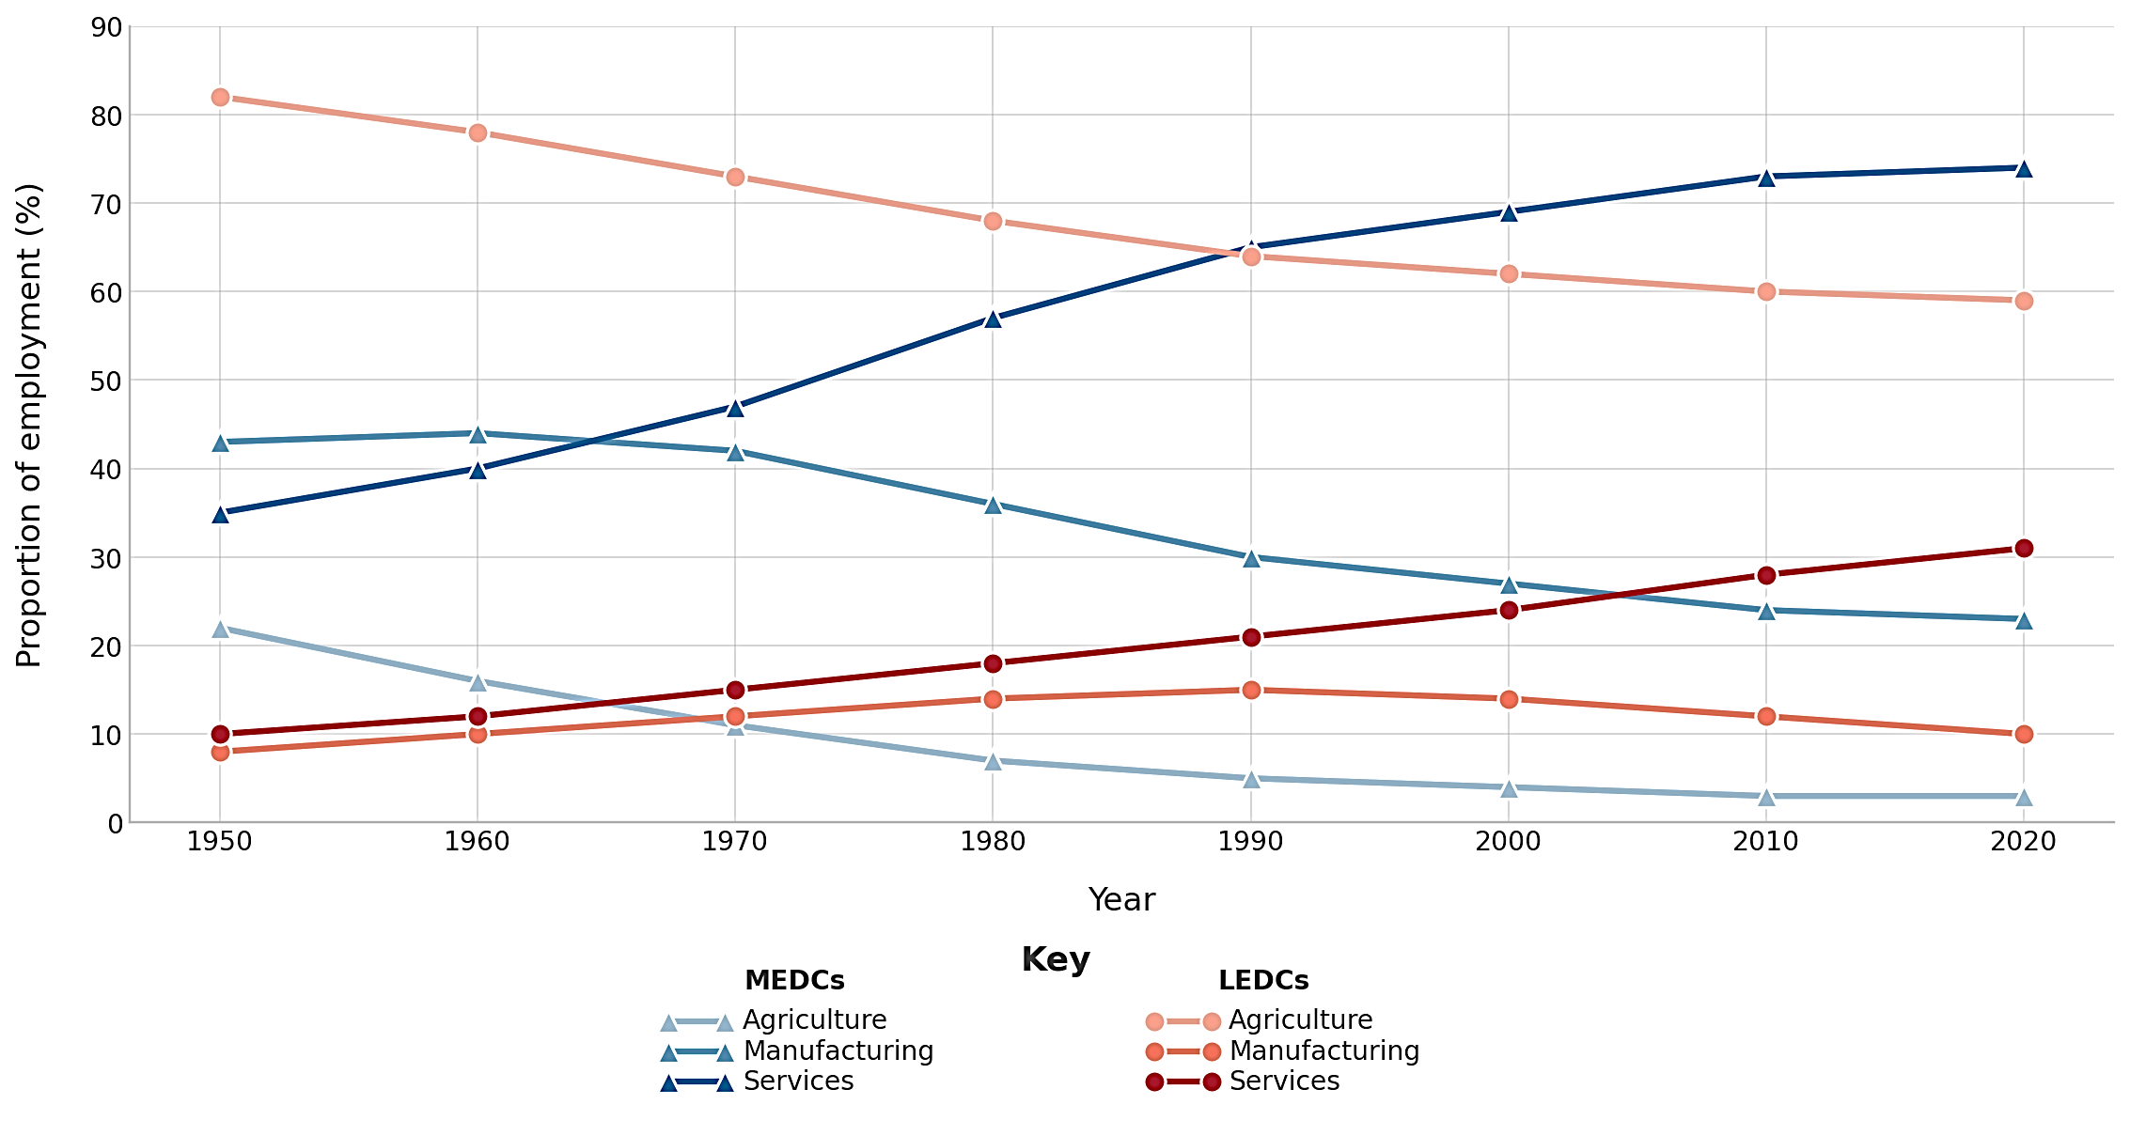

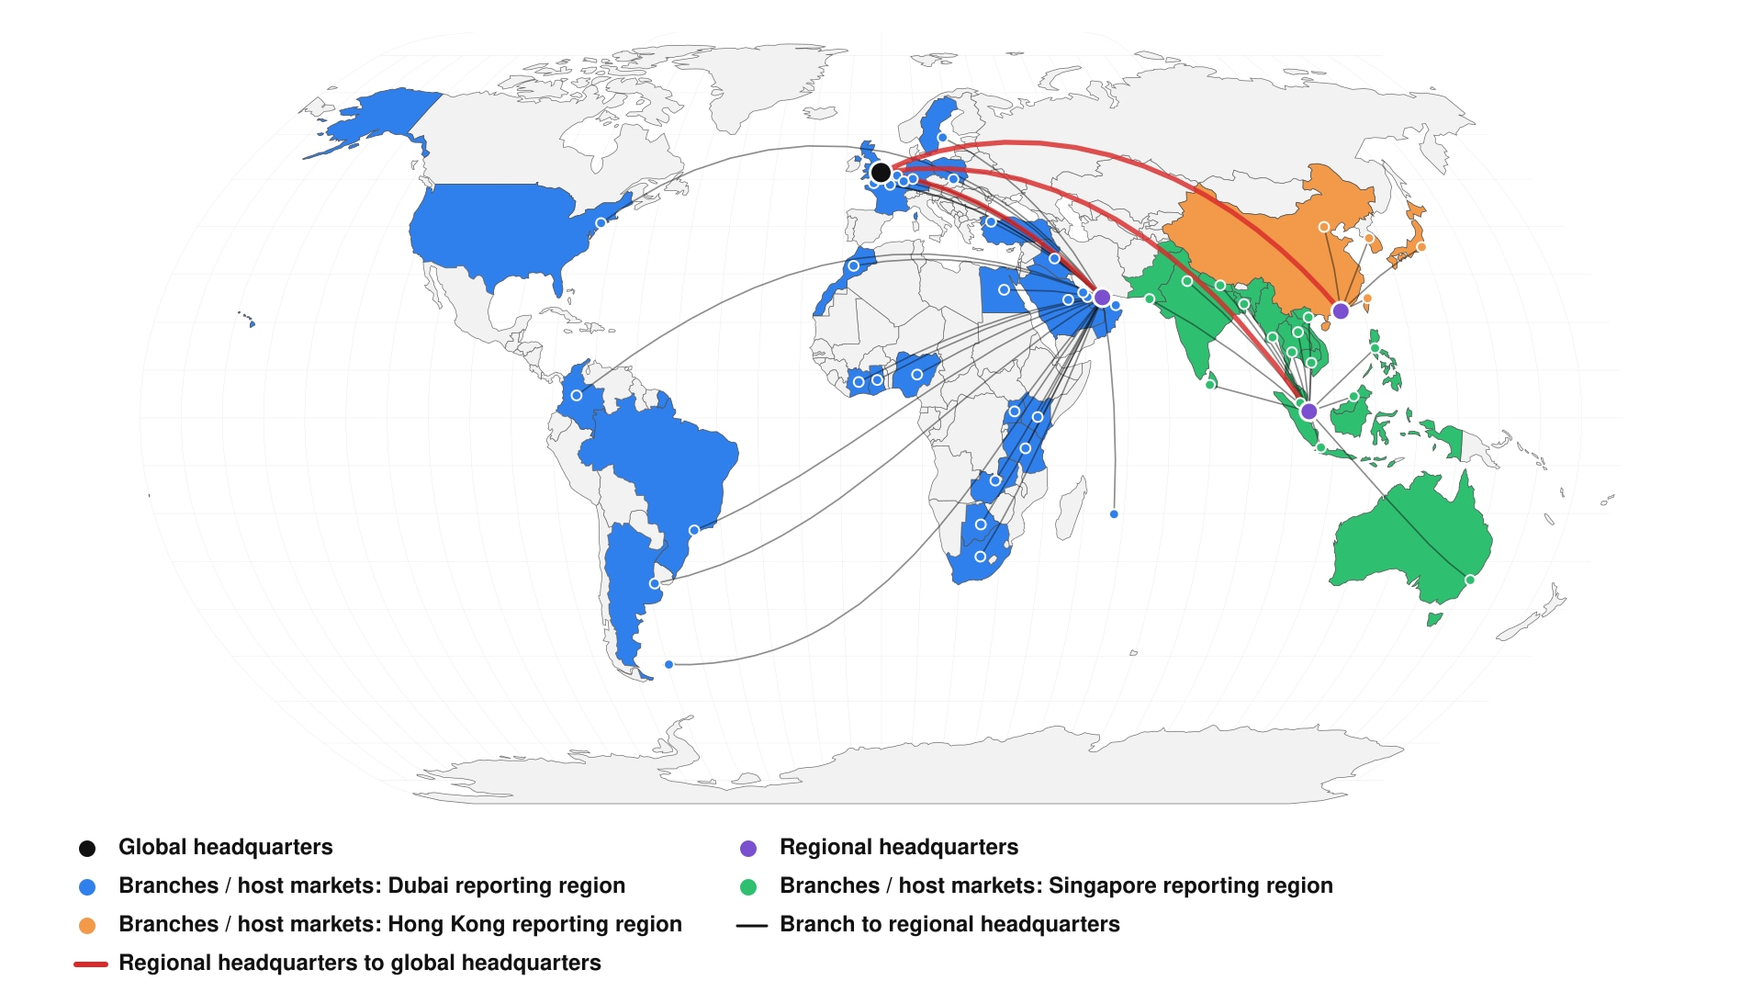
Resource 2 for Question 1
Spatial distribution of Standard Chartered Bank
London
Dubai
Singapore
Hong Kong
Resource 3 for Question 1
Map of the Colorado River Basin
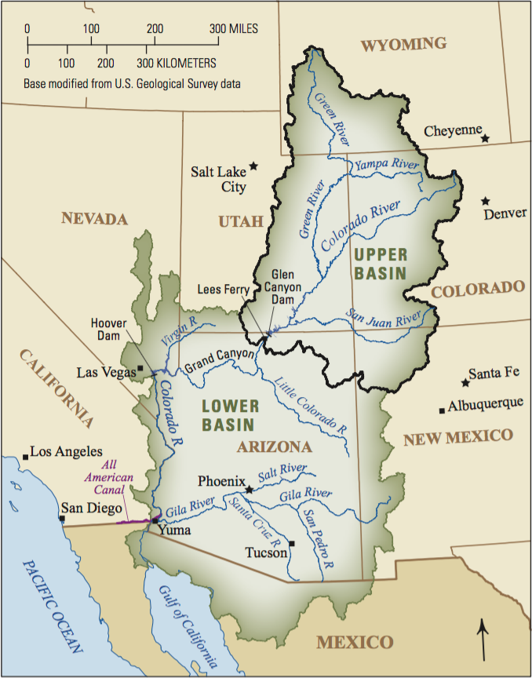
Much of the river basin is very arid. The upper basin is characterised by high elevations, narrow valleys, and a short growing season. The lower basin has lower elevations, wide basins and a long growing season.

Resource 4 for Question 2
Average annual precipitation levels in USA, 2005-2015
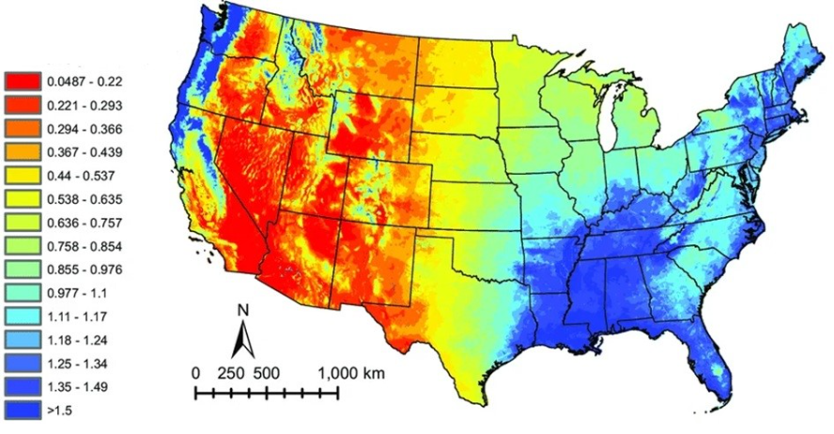

Resource 5 for Question 2
Water withdrawals per day in USA in 2015
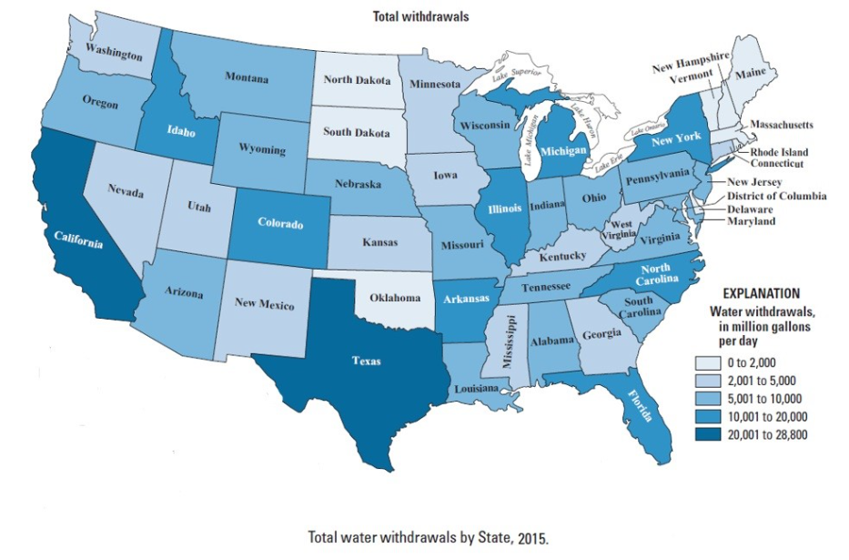

Resource 6 for Question 2
Trends in population and freshwater withdrawals from drainage basins in USA, 1950 - 2015
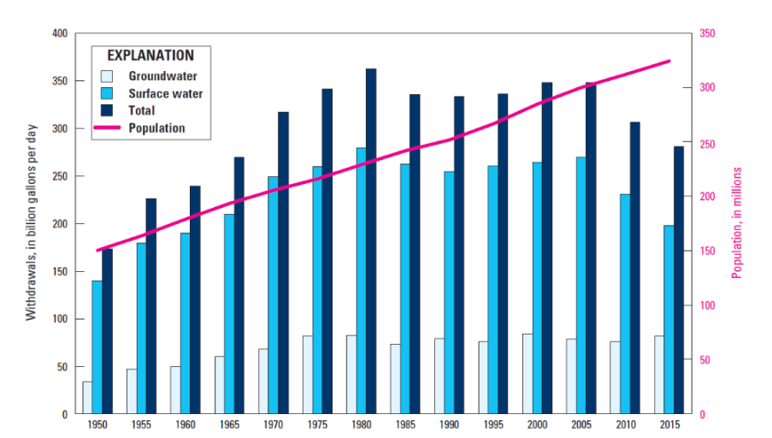

Resource 7 for Question 2
Predicted percentage change in flood risk in USA
